**PROJECT REPORT**

##### DBMS PROJECT

On

STUDENT MANAGEMENT SYSTEM

###### ***Submitted by***

##### SAYANDIP PAUL

RA1711008010322

***in partial fulfillment for the award of the degree of***

##### BACHELOR OF TECHNOLOGY

IN

**INFORMATION TECHNOLOGY**



OCTOBER 2019

S.NO TITLES PAGE

1. ER diagram 3-8

2. DDL/DML 9

3. SQL constraints 10

4. Retrieving data using select 11-12

5. Restrictions and sorting 13-14

6. Aggregate and grouping 15-16

7. Single row function 17-19

8. Joins 20-22

9. Subquery 23-24

10. Normalisation 25-28

###### **(1)ER DIAGRAM**

###### **STUDENT MANAGEMENT SYSTEM**

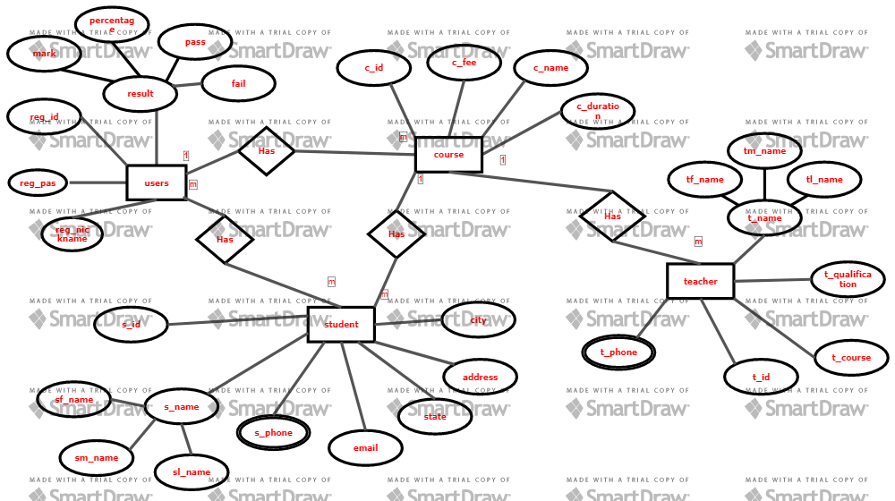

###### **ALL TABLES OF STUDENT MANAGEMENT SYSTEM**

SQL> create table student(s_id int NOT NULL PRIMARY KEY, f_name varchar(20),m_name varchar(20),l_name varchar(20),address varchar(20),city varchar(20),state varchar(20),email varchar(20));

Table created

SQL> create table s_phone(s_id int , FOREIGN KEY(s_id) REFERENCES student(s_id),phone int);

Table created

SQL> create table course(c_id int NOT NULL PRIMARY KEY,s_id int,FOREIGN KEY(s_id) REFERENCES student (s_id),c_fee int,c_name varchar(255),c_duration varchar(255));

Table created

SQL> create table teacher(t_id int NOT NULL PRIMARY KEY,tf_name varchar(20),tm_name varchar(20),tl_name varchar(20),c_id int, FOREIGN KEY (c_id) REFERENCES cousre(c_id),t_course varchar(255),t_qualification varchar(255));

Table created

SQL> create table t_phone(t_id int,FOREIGN KEY(t_id) REFERENCES teacher(t_id),t_phonenumber int);

Table created

SQL> create table users (s_id int,reg_id int not null,reg_nickname varchar(20),reg_password varchar(20),mark int,per int,pass varchar(20),fail varchar(20),FOREIGN KEY(s_id) REFERENCES student(s_id));

Table created

SQL> desc student;

Name Null? Type

----------------------------------------- -------- -------------------- S_ID NOT NULL NUMBER(38) F_NAME VARCHAR2(255) M_NAME VARCHAR2(255) L_NAME VARCHAR2(255) ADDRESS VARCHAR(255) CITY VARCHAR2(255) STATE VARCHAR2(255)

SQL> desc s_phone;

Name Null? Type

----------------------------------------- -------- --------------------

S_ID NUMBER(38)

PHONE NUMBER(38)

SQL> desc course;

Name Null? Type

----------------------------------------- -------- --------------------

C_ID NOT NULL NUMBER(38)

S_ID NUMBER(38)

C_FEE NUMBER(38)

C_NAME VARCHAR2(255)

C_DURATION VARCHAR2(255)

SQL> desc teacher;

Name Null? Type ----------------------------------------- -------- ------------------ T_ID NOT NULL NUMBER(38)

C_ID NUMBER(38)

TF_NAME VARCHAR2(255)

TM_NAME VARCHAR2(255)

TL_NAME VARCHAR2(255)

T_COURSE VARCHAR2(255)

T_QUALIFICATION VARCHAR2(255) SQL> desc t _phone; Name Null? Type ----------------------------------------- -------- -------------------- T_ID NUMBER(38) T_PHONENUMBER NUMBER(38)

SQL> desc users;

Name Null? Type ----------------------------------------- -------- -------------------- S_ID NUMBER(38)

REG_ID NOT NULL NUMBER(38)

REG_NICKNAME VARCHAR2(255)

REG_PASSWORD VARCHAR2(255)

MARK NUMBER(38)

PER VARCHAR2(255)

PASS VARCHAR2(255)

FAIL VARCHAR2(255)

###### **INSERT DATA TO TABLE**

###### STUDENT TABLE

SQL> insert into student(s_id,f_name,m_name,l_name,address,city,state)values(001,'sayan','dip','paul','alipurduar','chennai','tamilnadu'); 1 row created. SQL> insert into student(s_id,f_name,m_name,l_name,address,city,state)values(002,'alok','kumar','gupta','siliguri','alipur','westbengal'); 1 row created. SQL> insert into student(s_id,f_name,m_name,l_name,address,city,state)values(003,'amal','jit','mr','nandi','kochi','kerala'); 1 row created. SQL> insert into student(s_id,f_name,m_name,l_name,address,city,state)values(004,'arko','duti','mitra','balguria','kolkata','westbengal'); 1 row created. SQL> insert into student(s_id,f_name,m_name,l_name,address,city,state)values(005,'anish','kkr','thakur','dumdum','kolkata','westbengal'); 1 row created.

###### S_PHONE TABLE

SQL> insert into s_phone (s_id,phone) values (001,9944870714);

SQL> insert into s_phone (s_id,phone) values (002,7063101929);

SQL> insert into s_phone (s_id,phone) values (003, 9515438334);

SQL> insert into s_phone (s_id,phone) values (004, 7895463153);

SQL> insert into s_phone (s_id,phone) values (005, 9955446428);

###### COURSE TABLE

SQL> insert into course (c_id,s_id,c_fee,c_name,c_duration) values (11,001,25000

,'dbms','45_hr');

SQL> insert into course (c_id,s_id,c_fee,c_name,c_duration) values (12,002,45000

,'c++','45_hr');

SQL> insert into course (c_id,s_id,c_fee,c_name,c_duration) values (13,003,10200

0,'java','22_hr');

SQL> insert into course (c_id,s_id,c_fee,c_name,c_duration) values (14,004,10200

0,'python','52_hr');

SQL> insert into course (c_id,s_id,c_fee,c_name,c_duration) values (15,005,10200

,'pos','10_hr');

###### TEACHER TABLE

SQL> insert into teacher (t_id,c_id,tf_name,tm_name,tl_name,t_course,t_qualifica

tion) values (112,11,'sri','__','vidhya','dbms','phd');

SQL> insert into teacher (t_id,c_id,tf_name,tm_name,tl_name,t_course,t_qualifica

tion) values (115,12,'savri','__','dasan','c++','btech');

SQL> insert into teacher (t_id,c_id,tf_name,tm_name,tl_name,t_course,t_qualifica

tion) values (113,13,'jousaf','__','paul','java','btech');

SQL> insert into teacher (t_id,c_id,tf_name,tm_name,tl_name,t_course,t_qualifica

tion) values (114,14,'siva','__','jos','python','bsc');

SQL> insert into teacher (t_id,c_id,tf_name,tm_name,tl_name,t_course,t_qualifica

tion) values (111,15,'syu','mala','susi','pos','phd');

###### T_PHONE TABLE

SQL> insert into t_phone (t_id,phonenumber) values (111,9944875714);

SQL> insert into t_phone (t_id,phonenumber) values (112,7063101549);

SQL> insert into t_phone (t_id,phonenumber) values (113, 9515438224);

SQL> insert into t_phone (t_id,phonenumber) values (114, 7895415213);

SQL> insert into t_phone (t_id,phonenumber) values (115, 9215146428);

###### USER TABLE

SQL> insert into users (s_id,reg_id,reg_nickname,reg_password,mark,per,pass,fail

) values (001,20,'pala','xyz',900,90,'y','n');

1 row created.

SQL> insert into users (s_id,reg_id,reg_nickname,reg_password,mark,per,pass,fail

) values (002,21,'onis','zxy',800,80,'y','n');

1 row created.

SQL> insert into users (s_id,reg_id,reg_nickname,reg_password,mark,per,pass,fail

) values (003,22,'arko','zx',700,70,'y','n');

1 row created.

SQL> insert into users (s_id,reg_id,reg_nickname,reg_password,mark,per,pass,fail

) values (004,23,'baba','ons',300,30,'n','y');

1 row created.

SQL> insert into users (s_id,reg_id,reg_nickname,reg_password,mark,per,pass,fail

) values (005,24,'papa','rrv',400,40,'n','y');

###### **(2) DDL AND DML**

**1)Create a table name student and attribute of s_id,first last and middle name,address,email,city,state?**

SQL> create table student(s_id int NOT NULL PRIMARY KEY, f_name varchar(20),m_name varchar(20),l_name varchar(20),address varchar(20),city varchar(20),state varchar(20),email varchar(20));

**2)Display the datatype of all attribute’s in student table?**

SQL> desc student;

Name Null? Type

----------------------------------------- -------- -------------------- S_ID NOT NULL NUMBER(38) F_NAME VARCHAR2(255) M_NAME VARCHAR2(255) L_NAME VARCHAR2(255) ADDRESS VARCHAR(255) CITY VARCHAR2(255) STATE VARCHAR2(255)

**3)Insert values into the table student?**

SQL> insert into student(s_id,f_name,m_name,l_name,address,city,state)values(001,'sayan','dip','paul','alipurduar','chennai','tamilnadu');

**4)Change the datatype of s_id in student table?**

SQL> alter table student modify s_id varchar(20);

**5)Update the city of s_id=001 to bby?**

SQL>update student set city=’bby’ where s_id=001;

###### **RESULT**

DDL and DML command executed successfully.

###### **(3) SQL CONSTRAINTS**

**1)Create a table name student and with a attribute s_id which is not null?**

SQL>create table student(s_id int not null,age int);

Table created

**2) Create a table name student and with a attribute s_id which is unique?**

SQL>create table stydent(s_id int unique,age int);

Table created

**3)Create a table name student and with a attributes s_id which is a primary key?**

SQL>create table stydent(s_id int primary key,age int);

Table created

**4)Create a table name teacher and with a attributes s_id which is a foreign key and team name?**

SQL>create table teacher(s_id int,foreign key(s_id) referances (s_id),t_name varchar(20));

Table created

**5)Create a table name student and with a attributes city which a default constraints “KOLKATA”?**

SQL>create table student(s_id int,city varchar(20) default ‘KOLKATA’);

Table created

###### **RESULT**

SQL constraints command executed successfully.

###### **(4) RETRIEVING DATA USING SELECT**

**1)Display all the columns of table name course?**

SQL> select * from course;

## OUTPUT

C_ID S_ID C_FEE C_NAME C_DURATION

---------- ---------- ---------- -------------------- --------------------

11 1 25000 dbms 45_hr

12 2 45000 c++ 45_hr

13 3 102000 java 22_hr

**2)Display the columns c_name aliases coursename of table name course?**

SQL>select c_name as coursename from course;

## OUTPUT

COURSEFEE --------------------

dbms

c++

java

**3)Display the columns c_fee and c_name using concatenation and aliases coursedetails of table name course?**

SQL>select c_fee || c_name as coursedetails from course;

## OUTPUT

COURSEDETAILS --------------------------------------- 25000 dbms

45000 c++

102000 java

**4)Display the course fee and increase in course fee by 3000 where course duration is 45_hr?**

SQL>select c_fee,c_fee+3000 from course where c_duration = ‘45_hr’;

## OUTPUT

C_FEE C_FEE+3000 C_DURATION

---------- -------------------- --------------------

25000 28000 45_hr

45000 48000 45_hr

**5)Remove the duplicate value from course durartion with student ID from table name course?**

SQL>select distinct c_duration,s_id from course;

## OUTPUT

S_ID C_DURATION

------------- --------------------

1 45_hr

3 22_hr

###### **RESULT**

Retrieving data using select command executed successfully.

###### **(5) RESTRICTIONS AND SORTING**

**1)Display the student ID and first name from table name student who’s state is westbengal?**

SQL>select s_id,f_name from student where state = ‘westbengal’;

## OUTPUT

S_ID F_NAME

------------- ------------------

2 alok

4 arko

5 anish

**2)Display all the data of table course who’s course ID is ‘11’?**

SQL>select * from course where c_id = 11;

## OUTPUT

C_ID S_ID C_FEE C_NAME C_DURATION

---------- ---------- ---------- -------------------- --------------------

11 1 25000 dbms 45_hr

**3)Display all the data of table course who’s course fee range in less then 100000?**

SQL>select * from course where c_fee < 100000;

## OUTPUT

## C_ID S_ID C_FEE C_NAME C_DURATION ---------- ---------- ---------- -------------------- ------------------- 11 1 25000 dbms 45_hr

12 2 45000 c++ 45_hr

15 5 10200 pos 10_hr

**4)Display the lastname and city of table student where student first name start with ‘a’ consist of 4 character?**

SQL>select l_name,city from student where f_name = ‘a% _ _ _ ‘;

## OUTPUT

## L_NAME CITY

------------------- - --------------------

gupta alipur

amla kochi

arko Kolkata

**5)Display the course fee of table name course which in between 10000 to 50000?**

SQL>select s_id,c_id,c_fee from course where c_fee in between(10000,50000);

## OUTPUT

S_ID C_ID C_FEE

---------- ------------- ------------------------------

1 11 25000

2 12 45000

5 15 10200

###### **RESULT**

RESTRICTIONS AND Sorting command executed successfully.

###### **(6) AGGREGATE AND GROUPING**

**1)Display the average course fee for all the course in the given table?**

SQL>select avg(c_fee) from course;

## OUTPUT

AVG(C_FEE) ---------------

56840

**2)Display the minimum and maximum course fee in the given table?**

SQL>select min(c_fee),max(c_fee) from course;

## OUTPUT

MIN(C_FEE) MAX(C_FEE) ---------------- ---------------

10200 102000

102000

**3)Display the count number of course name from table name course?**

SQL>select count(c_name) from course;

## OUTPUT

COUNT(C_NAME) ----------------------------------- 5

**4)Display the total of course fee in the table name course?**

SQL>select sum(c_fee) from course;

## OUTPUT

SUM(C_NAME -----------------

284200

**5)Display the student ID and minimum course fee from coure table and group by student ID having course fee less then 102000 and sort the minimum course fee in descending order?**

SQL>select s_id,min(c_fee) from course group by s_id having c_fee < 102000 order by min(c_fee) desc;

## OUTPUT

S_ID MIN(C_FEE)

---------- -------------

5 10200

1 25000

2 45000

###### **RESULT**

Aggregate and grouping command executed successfully.

###### **(7) SINGLE ROW FUNCTION**

**1)Display the student ID and student first name and state from student table where convert student first name and state into uppercase?**

SQL>select s_id,upper(f_name),upper(l_name) from student;

## OUTPUT

S_ID UPPER(L_NAME) UPPER(STATE)

------- --------------------------- --------------------

1 PAUL WESTBENGAL

2 GUPTA WESTBENGAL

3 MR KERALA

4 MITRA WESTBENGAL

5 THAKUR WESTBENGAL

**2)Display the student ID and student first name and state from student table where convert student first name and state into lowercase?**

SQL> select s_id,lower(f_name),lower(l_name) from student;

## OUTPUT

S_ID UPPER(L_NAME) UPPER(STATE)

------- ------------------ --------------------

1 paul westbengal

2 gupta westbengal

3 mr kerala

4 mitra westbengal

5 thakur westbengal

**3)Display the student ID and student state from table student and change the first character of all state to uppercase?**

SQL>select s_id,initcap(state) from student;

## OUTPUT

S_ID INITCAP(STATE)

------- --------------------

1 Westbengal

2 Westbengal

3 Kerala

4 Westbengal

5 Westbengal

**4)Display the student ID and student first name middle name last name together from the table student use the character-manipulation function?**

SQL>select s_id,concat(f_name,m_name,l_name) student_name from student;

## OUTPUT

S_ID STUDENT_NAME

------- --------------------

1 sayandippaul

2 alokkumargupta

3 amaljitmr

4 arkodutimitra

5 anishkkrthakur

**5)Display the student ID and the length of the first name and the last name from the table student use the character-manipulation function?**

SQL>select s_id,f_name,length(f_name),l_name,length(l_name) from student;

## OUTPUT

S_ID F_NAME LENGTH(F_NAME) L_NMAE LENGTH(L_NAME)

------- -------------- ------------------ --------------- -------------------

1 sayan 5 paul 4

2 alok 4 gupta 5

3 amal 4 mr 2

4 arko 4 mitra 5

5 anish 5 thakur 6

###### **RESULT**

Single row function command executed successfully.

###### **(8) JOINS**

**1)Display the registration number fo usres table and student first namefrom the table student use inner join?**

SQL>select users.reg_id,student.f_name from users inner join student on users.s_id = student.s_id;

## OUTPUT

REG_ID F_NAME

------------- ----------------------

20 sayan

21 alok

22 amal

23 arko

24 anish

**2) Display the registration number fo usres table and student first namefrom the table student use left join and order by first name?**

SQL>select student.f_name,users.reg_id from users left join student on users.s_id = student.s_id order by student.f_name;

## OUTPUT

F_NAME REG_ID

---------------------- --------------------

alok 21

amal 22

anish 24

arko 23

sayan 20

**3) Display the registration number fo usres table and student first name and last name from the table student use right join and order by registration number?**

SQL>select users.reg_id,student.f_name,student.l_name from student right join student on usres.s_id = student.s_id order by users.reg_id;

## OUTPUT

REG_ID F_NAME L_NAME

---------------- ------------------ ---- ------------------

20 sayan paul

21 alok gupta

22 amal mr

23 arko mitra

24 anish thakur

**4)Select all teacher and all course in the given table use full join and order by teacher ID?**

SQL>select teacher.t_id,course.c_name from course full join course on tescher.c_id = course.c_id order by teacher.t_id;

## OUTPUT

T_ID C_NAME

----------- -----------------

111 pos

112 dbms

113 java

114 python

115 c++

**5) Select all student first name and last name and city in the given table use self join and order by city?**

SQL>select A.f_name as s_name1,B.l_name as s_name2,A.city from student A,student B where A.s_id <> B.s_id and A.city = B.city order by A.city;

## OUTPUT

S_NAME1 S_NAME2 CITY

---------- ---------- -----------

sayan gupta alipur

alok paul chennai

amal thakur kochi

anish mitra kolkata

arko mr kolkata

###### **RESULT**

**JIONS all command executed successfully.**

###### **(9) SUBQUERY**

**1)Display the first middle and last name of student where the course fee is minimum?**

SQL>select f_name,m_name,l_name from student where s_id =(select s_id from course where s_id = min(c_fee));

## OUTPUT

F_NAME M_NAME L_NAME

------------- ------------- --------------

anish kkr thakur

**2) Display the teacher ID and first middle and last name of teacher where the course name is dbms?**

SQL> select t_id,tf_name,tm_name,tl_name from teacher where c_id =(select c_id from course where t_course = ‘dbms’);

## OUTPUT

T_ID TF_NAME TM_NAME TL_NAME

----------- ------------------ -------------- --------------

112 sri __ vidhya

**3)Display the phone number of the student of who’s registration number is 20?**

SQL>select phone from s_phone where s_id = (select s_id from users where r_id = 20);

## OUTPUT

PHONE

--------------

9944870714

**4)Display registration number who live in alipur?**

SQL>select r_id from users where s_id = (select s_id from student where city = ‘alipur’);

## OUTPUT

REG_ID

----------------

21

**5)Display teacher ID first name and phonenumber who’s qualification is b.tech?**

SQL>select t_id,tf_name,phone from t_phone where t_id = (select t_id from teacher where t_qualification = ‘b.tech’);

## OUTPUT

T_ID TF_NAME PHONE

--------- ----------- ---------------

113 jousaf 6541239575

115 savri 8235658254

###### **RESULT**

**SUBQUERY all command executed successfully.**

###### **(10) NORMALISATION**

**NORMAL FORM (1NF,2NF,3NF)**

**TABLE STUDENT**

##### Annotation 2019-10-08 024334.png

TABLE S_PHONE

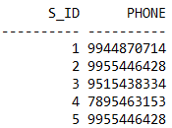

TABLE COURSE

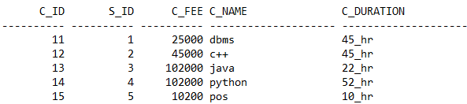

TABLE TEACHER

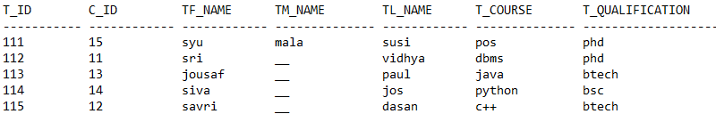

TABLE T_PHONE

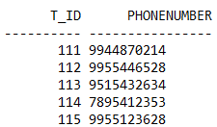

TABLE USRES

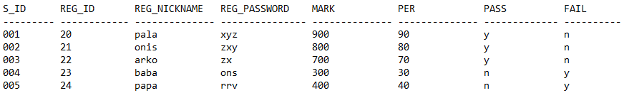

* This table satisfy all the rule of 1NF:-

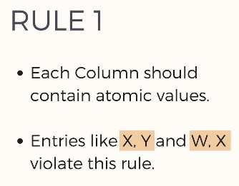

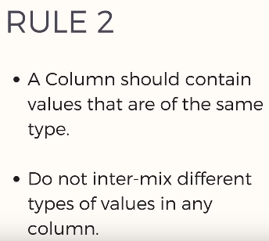

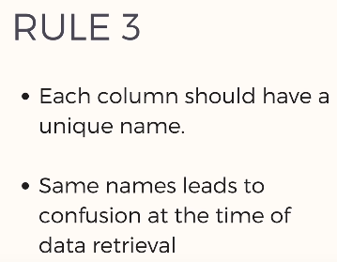

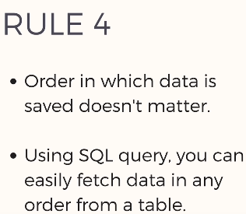

* + This table satisfy all the rule of 2NF:-

RULE

* It should be in 1st normal form.
* It should not have partial dependencies.
* This table satisfy all the rule of 3NF:-

RULE

* + It should be in 2nd normal form.
  + It should not have transitive dependencies.

###### **RESULT**

The table’s of this student management system satisfy all the normal form(1NF,2NF,3NF).